BANK LOAN REPORT QUERY DOCUMENT
- Bank Loan Report | Summary

KPI’s:
- Loan Applications

- Total Loan Applications
SELECT COUNT(id) AS Total_Applications FROM bank_loan_data;

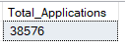

- MTD Loan Applications
SELECT COUNT(id) AS Total_Applications FROM bank_loan_data
WHERE MONTH(issue_date) = 12;

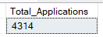

- PMTD Loan Applications
SELECT COUNT(id) AS Total_Applications FROM bank_loan_data
WHERE MONTH(issue_date) = 11;
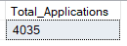
- Total Funded Amount

- Total funded Amount
SELECT SUM(loan_amount) AS Total_Funded_Amount FROM bank_loan_data;

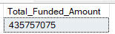

- MTD Total Funded Amount
SELECT SUM(loan_amount) AS Total_Funded_Amount FROM bank_loan_data
WHERE MONTH(issue_date) = 12;

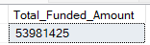

- PMTD Total Funded Amount
SELECT SUM(loan_amount) AS Total_Funded_Amount FROM bank_loan_data
WHERE MONTH(issue_date) = 11;
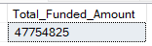

- Amount Received
- Total Amount Received
SELECT SUM(total_payment) AS Total_Amount_Collected FROM bank_loan_data
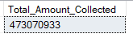

- MTD Total Amount Received
SELECT SUM(total_payment) AS Total_Amount_Collected FROM bank_loan_data
WHERE MONTH(issue_date) = 12

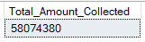

- PMTD Total Amount Received
SELECT SUM(total_payment) AS Total_Amount_Collected FROM bank_loan_data
WHERE MONTH(issue_date) = 11

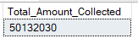

- Amount Collected

- Total Amount Received
SELECT SUM(total_payment) AS Total_Amount_Collected FROM bank_loan_data

- MTD Total Amount Received
SELECT SUM(total_payment) AS Total_Amount_Collected FROM bank_loan_data
WHERE MONTH(issue_date) = 12

- PMTD Total Amount Received
SELECT SUM(total_payment) AS Total_Amount_Collected FROM bank_loan_data
WHERE MONTH(issue_date) = 11

- Interest Rate
- Average Interest Rate
SELECT AVG(int_rate)*100 AS Avg_Int_Rate FROM bank_loan_data

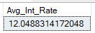

- MTD Average Interest
SELECT AVG(int_rate)*100 AS MTD_Avg_Int_Rate FROM bank_loan_data
WHERE MONTH(issue_date) = 12

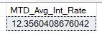

- PMTD Average Interest
SELECT AVG(int_rate)*100 AS PMTD_Avg_Int_Rate FROM bank_loan_data
WHERE MONTH(issue_date) = 11

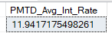

- DTI
- Average DTI
SELECT AVG(dti)*100 AS Avg_DTI FROM bank_loan_data

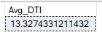

- MTD Average DTI
SELECT AVG(dti)*100 AS MTD_Avg_DTI FROM bank_loan_data
WHERE MONTH(issue_date) = 12

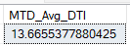

- PMTD Average DTI
SELECT AVG(dti)*100 AS PMTD_Avg_DTI FROM bank_loan_data
WHERE MONTH(issue_date) = 11

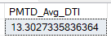

GOOD LOAN ISSUED

-> Good Loan Percentage
SELECT ROUND(COUNT(CASE WHEN loan_status = 'Fully Paid' OR loan_status = 'Current' THEN id END) * 100.0) / COUNT(id),2) AS Good_Loan_Percentage FROM bank_loan_data;
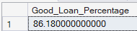
->Good Loan Applications
SELECT COUNT(id) AS Good_Loan_Applications FROM bank_loan_data
WHERE loan_status = 'Fully Paid' OR loan_status = 'Current'
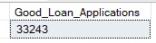
->Good Loan Funded Amount
SELECT SUM(loan_amount) AS Good_Loan_Funded_amount FROM bank_loan_data
WHERE loan_status = 'Fully Paid' OR loan_status = 'Current'
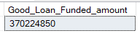
->Good Loan Amount Received
SELECT SUM(total_payment) AS Good_Loan_amount_received FROM bank_loan_data
WHERE loan_status = 'Fully Paid' OR loan_status = 'Current'


BAD LOAN ISSUED

Bad Loan Percentage
SELECT ROUND(COUNT(CASE WHEN loan_status = 'Charged Off' THEN id END) * 100.0 / COUNT(id),2) AS Bad_Loan_Percentage FROM bank_loan_data;

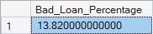
Bad Loan Applications
SELECT COUNT(id) AS Bad_Loan_Applications FROM bank_loan_data
WHERE loan_status = 'Charged Off'
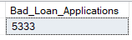
Bad Loan Funded Amount
SELECT SUM(loan_amount) AS Bad_Loan_Funded_amount FROM bank_loan_data
WHERE loan_status = 'Charged Off'
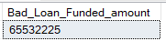

Bad Loan Amount Received
SELECT SUM(total_payment) AS Bad_Loan_amount_received FROM bank_loan_data
WHERE loan_status = 'Charged Off'
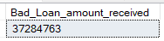
LOAN STATUS
- Total Amount

SELECT
loan_status,
COUNT(id) AS LoanCount,
SUM(total_payment) AS Total_Amount_Received,
SUM(loan_amount) AS Total_Funded_Amount,
AVG(int_rate * 100) AS Interest_Rate,
AVG(dti * 100) AS DTI
FROM bank_loan_data GROUP BY loan_status;
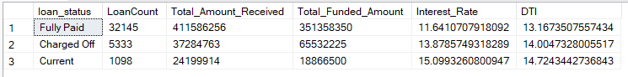

- MTD

SELECT
loan_status,
SUM(total_payment) AS MTD_Total_Amount_Received,
SUM(loan_amount) AS MTD_Total_Funded_Amount
FROM bank_loan_data
WHERE MONTH(issue_date) = 12
GROUP BY loan_status
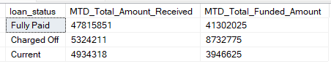

- PMTD

SELECT
loan_status,
SUM(total_payment) AS PMTD_Total_Amount_Received,
SUM(loan_amount) AS PMTD_Total_Funded_Amount FROM bank_loan_data
WHERE MONTH(issue_date) = 11
GROUP BY loan_status
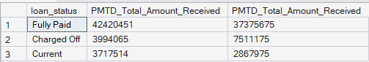

- BANK LOAN REPORT | OVERVIEW

- MONTH
SELECT
MONTH(issue_date) AS Month_Munber,
DATENAME(MONTH, issue_date) AS Month_name,
COUNT(id) AS Total_Loan_Applications,
SUM(loan_amount) AS Total_Funded_Amount,
SUM(total_payment) AS Total_Amount_Received
FROM bank_loan_data
GROUP BY MONTH(issue_date), DATENAME(MONTH, issue_date)
ORDER BY MONTH(issue_date);
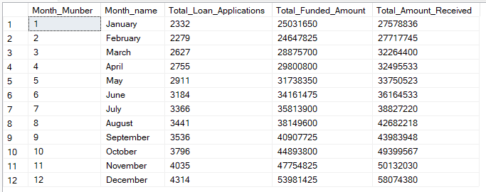

- STATE
SELECT
address_state AS State,
COUNT(id) AS Total_Loan_Applications,
SUM(loan_amount) AS Total_Funded_Amount,
SUM(total_payment) AS Total_Amount_Received
FROM bank_loan_data
GROUP BY address_state
ORDER BY address_state
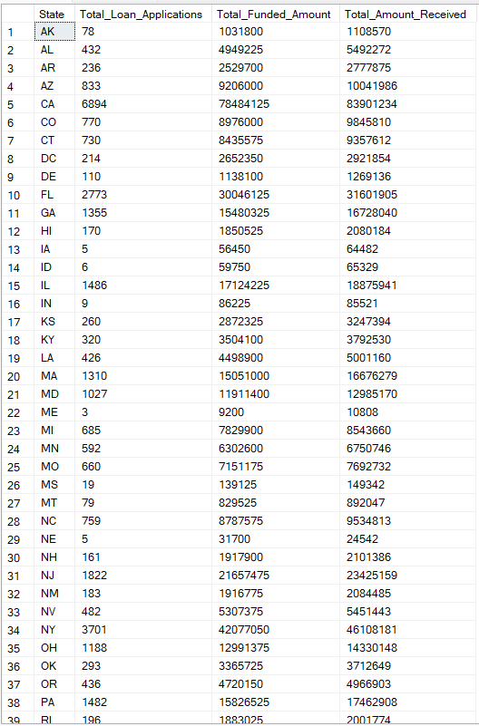

- TERM
SELECT
term AS Term,
COUNT(id) AS Total_Loan_Applications,
SUM(loan_amount) AS Total_Funded_Amount,
SUM(total_payment) AS Total_Amount_Received
FROM bank_loan_data
GROUP BY term
ORDER BY term
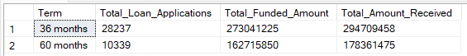

- EMPLOYEE LENGTH
SELECT
emp_length AS Employee_Length,
COUNT(id) AS Total_Loan_Applications,
SUM(loan_amount) AS Total_Funded_Amount,
SUM(total_payment) AS Total_Amount_Received
FROM bank_loan_data
GROUP BY emp_length
ORDER BY emp_length
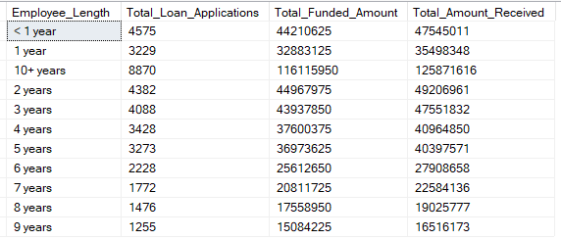

- PURPOSE
SELECT
purpose AS PURPOSE,
COUNT(id) AS Total_Loan_Applications,
SUM(loan_amount) AS Total_Funded_Amount,
SUM(total_payment) AS Total_Amount_Received FROM bank_loan_data
GROUP BY purpose ORDER BY purpose
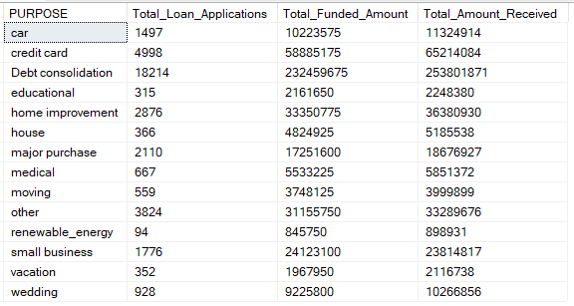
- HOME OWNERSHIP
SELECT
home_ownership AS Home_Ownership,
COUNT(id) AS Total_Loan_Applications,
SUM(loan_amount) AS Total_Funded_Amount,
SUM(total_payment) AS Total_Amount_Received
FROM bank_loan_data
GROUP BY home_ownership
ORDER BY home_ownership
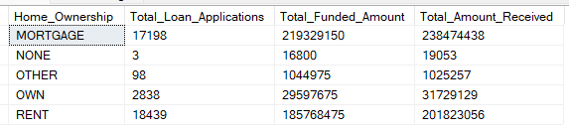

- A special column which consist of grade can also be used to sort good purpose loan data
SELECT
purpose AS PURPOSE,
COUNT(id) AS Total_Loan_Applications,
SUM(loan_amount) AS Total_Funded_Amount,
SUM(total_payment) AS Total_Amount_Received
FROM bank_loan_data
WHERE grade = 'A'
GROUP BY purpose
ORDER BY SUM(loan_amount) DESC;

ADVANCE QUERY’s

- Rank loan grades by total funded amount

SELECT grade,
SUM(loan_amount) AS TOTAL_AMOUNT_FUNDED,
RANK() OVER(ORDER BY SUM(loan_amount) DESC )AS GRADE_RANK
FROM bank_loan_data
GROUP BY GRADE
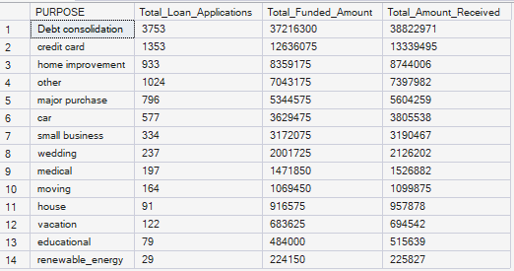

- Top 3 loans in every sub-grade
WITH ranked_loan AS(
SELECT
id,
member_id,
sub_grade,
loan_amount,
ROW_NUMBER() OVER(PARTITION BY SUB_GRADE ORDER BY loan_amount DESC) AS LOAN_RANK
FROM bank_loan_data)
SELECT *
FROM ranked_loan
WHERE LOAN_RANK<=3; ##( Here we didn’t use rank or dense_rank bcz multiple sub grade have same loan_amount)
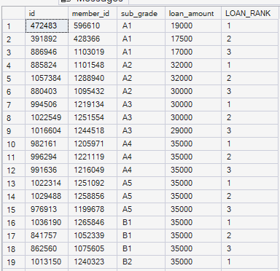
- Loans with above-average interest rate
select
id,
member_id,
int_rate,
round(int_rate-(select avg(int_rate) from bank_loan_data),3) as Difference_fram_avg
from bank_loan_data
where int_rate>(select avg(int_rate) from bank_loan_data);

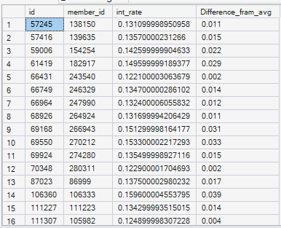

- Comparing monthly applications with previous month

with monthly_data as(
select
month(issue_date) as month_number,
datename(month,issue_date) as month_name,
count(id) as total_applications
from bank_loan_data
group by MONTH(issue_date),datename(month,issue_date)
),
previous_month as(
select *,
lag(total_applications) over(order by month_number) as previous_month_applications
from monthly_data)
select
month_name,
total_applications,
previous_month_applications,
total_applications-previous_month_applications as mom_change,
round((total_applications-previous_month_applications )*100.00/previous_month_applications, 2)
from previous_month;

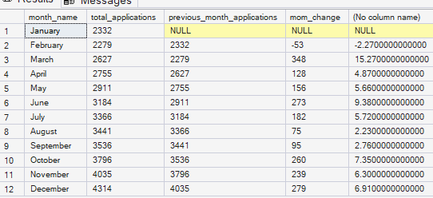

- Each borrower highest loan amount

WITH ranked_loans AS (
SELECT
member_id,
id,
loan_amount,
issue_date,
ROW_NUMBER() OVER (
PARTITION BY member_id
ORDER BY loan_amount DESC
) AS loan_rank
FROM bank_loan_data
)
SELECT
member_id,
id,
loan_amount,
issue_date
FROM ranked_loans
WHERE loan_rank = 1;

- Cumulative funded amount

WITH monthly_funding AS (
SELECT
MONTH(issue_date) AS month_num,
datename(month,issue_date) AS month_name,
SUM(loan_amount) AS monthly_funded
FROM bank_loan_data
GROUP BY
MONTH(issue_date),
dateNAME(month,issue_date)
)
SELECT
month_name,
monthly_funded,
SUM(monthly_funded) OVER (order by month_num) AS cumulative_funded
FROM monthly_funding
ORDER BY month_num;
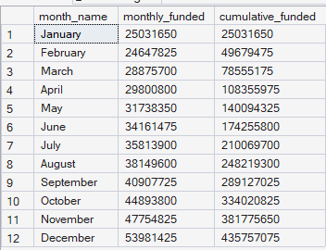

- Highest interest loan in each employment group

with data as(
select
emp_length,
id,
member_id,
int_rate,
DENSE_RANK() OVER(PARTITION BY emp_length
order by int_rate desc) as interest_rank from bank_loan_data)
select * from data
where interest_rank=1;
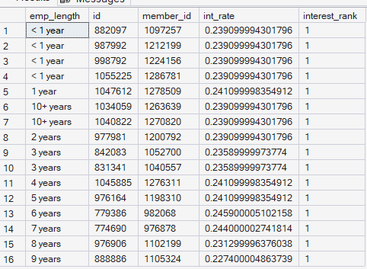
- Comparing each borrower current loan with previous loans
WITH LOAN_HISTORY AS(
SELECT
member_id,
id,
issue_date,
loan_amount,
LAG(LOAN_AMOUNT) OVER(PARTITION BY MEMBER_ID ORDER BY issue_date) AS PREVIOUS_LOAN_AMOUNT
FROM bank_loan_data)
SELECT
member_id,
id,
issue_date,
loan_amount,
PREVIOUS_LOAN_AMOUNT,
loan_amount-PREVIOUS_LOAN_AMOUNT AS CHANGE_AMOUNT
FROM LOAN_HISTORY
WHERE PREVIOUS_LOAN_AMOUNT IS NOT NULL AND loan_amount> PREVIOUS_LOAN_AMOUNT;

